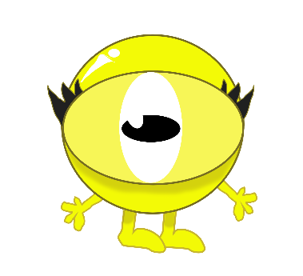
Dear Parents
We know that children learn best when parents and teachers follow the same methods. Working in the same way is vital for reinforcing learning. So here is some information to help you use the Monster Phonics approach which your child is following at school.
Monster Phonics accelerates progress, so it is important to use this approach at home whenever you are helping your child with phonics or learning spellings.
Your school will share your parent login with you. Use this to access Monster Phonics resources. Each week, you child’s class teacher will share their current learning with you. They may suggest that you have a go at certain activities or watch specific videos at home. They may also suggest that you download resources such as Flashcards and PowerPoints to support home learning.
If your school has access to eBooks, they will share a link with you to create your own account. You will be sent separate guidance for this.

To Log in
Click Monster Phonics Programme in the blue menu bar. Then click Lessons or click on the link shared by your child’s teacher. Follow our Parent Guide to help you best support your child reading Monster Phonics books.

The Monster Phonics Reading Scheme
The next pages outline the way Monster Phonics works. Monster Phonics makes learning fun and more memorable. Rather than relying on rote learning, Monster Phonics uses colour-coding to promote understanding, which leads to children becoming confident, independent learners. Confidence builds their passion for school and for life.

Please get in touch if you need any help or have any questions.
Best wishes,
The Monster Phonics Team info@monsterphonics.com
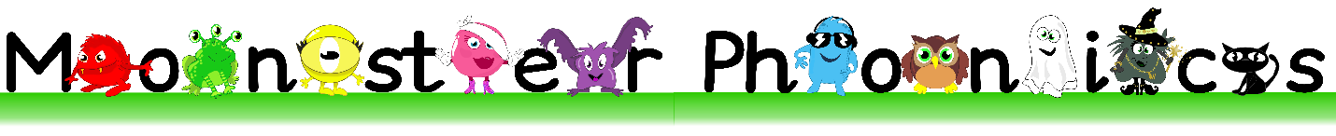

What is Monster Phonics?
The 26 letters of the alphabet and combinations of these letters make 44 speech sounds in English. The 44 sounds (phonemes) are spelt by 144 different letter combinations (graphemes). For example, the sound A is spelt several different ways, including ay (play) and ai (train).
Traditional ways of learning to spell can be time-consuming and for some children they are ineffective. Monster Phonics teaches children to read by enabling them to identify the individual graphemes (letter combinations) ad blend the sounds (phonemes) together to read the word.
To support this process, Monster Phonics uses the 10 monsters to categorises all sounds into 10 simple areas. Furthermore, each monster has a different colour and that colour represents that way of spelling the sound.
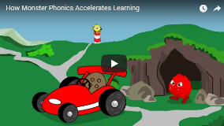
Watch the video

Find out more about how Monster Phonics works
Visit https://monsterphonics.com/how-it-works/
Why does it improve learning?

The child learns through the assignment of colour and the linkage of the sound, as well as seeing the colour, creating more ways of remembering the spelling.
Your teacher will be using games, songs and activities that continuously reflect this way of learning, so that structure is constantly seen, heard and experienced by your child. This consistency is critical in ensuring that a complicated language is learnt in the most simplistic way. Therefore it is essential that you use Monster Phonics.

Find out more about Monster Phonics
- Attend one of our Parent Webinars
- Read an eBook
- Watch a Monster Phonics Story Time
- Read a review and if you like Monster Phonics, add one too!

Meet the Monsters

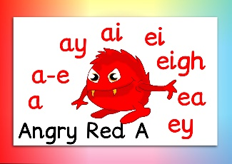
Long A sound

Long E sound
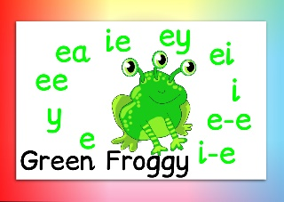

Long I sound
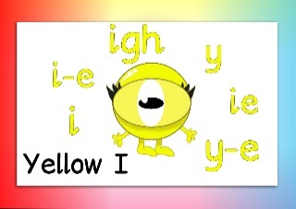

Long O sound
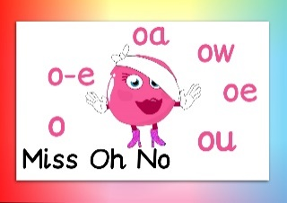

Long U sound
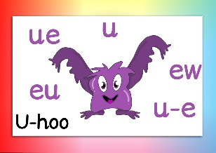

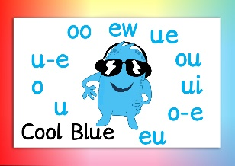
Long oo sound

Long ow sound
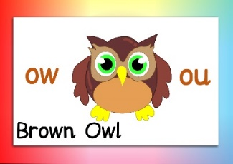

Silent Letters that have no sound
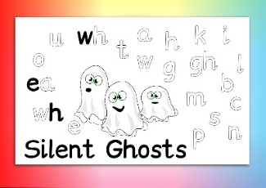

Tricky Letters that make a different sound
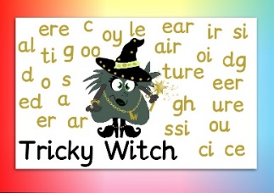

Black Cats – phonetic letters
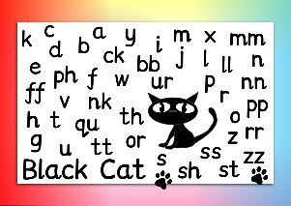

Monster Phonics Products
Spelling Books
Colour-coded for sound to accelerate learning, our spelling log books cover all KS1 graphemes and spelling rules. Ideal for your weekly spellings and home-learning!
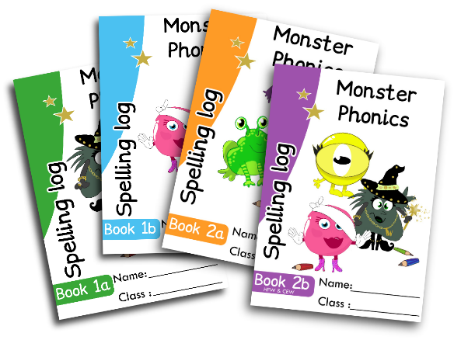

Email info@monsterphonics.com to order or buy online from our website shop https://monsterphonics.com/shop/
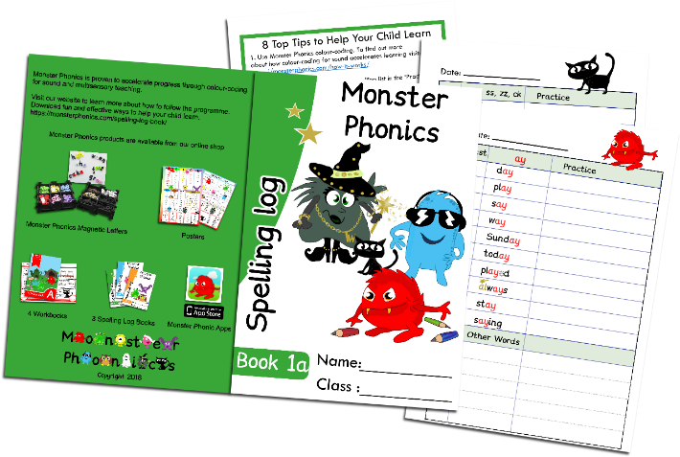

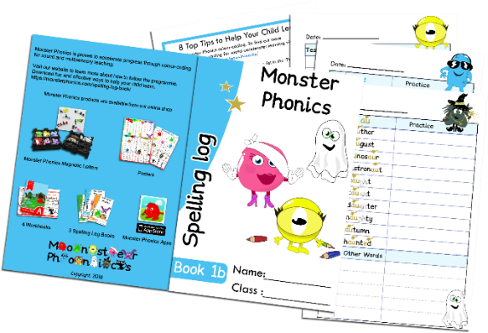
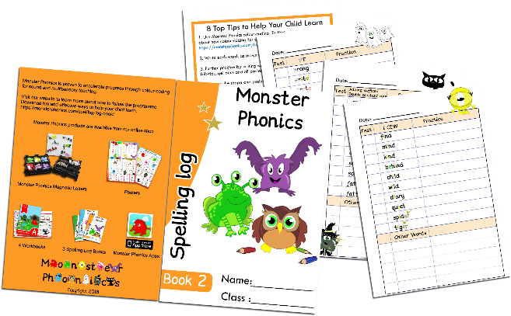

A1 Posters
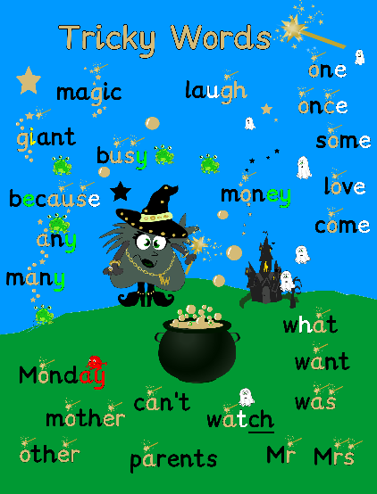
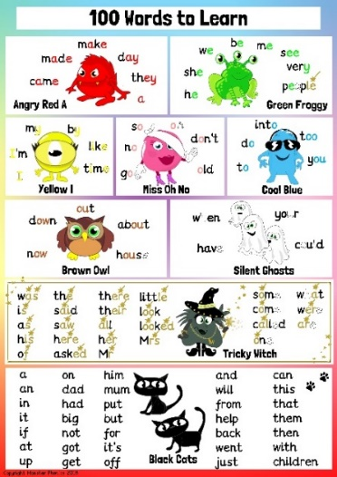
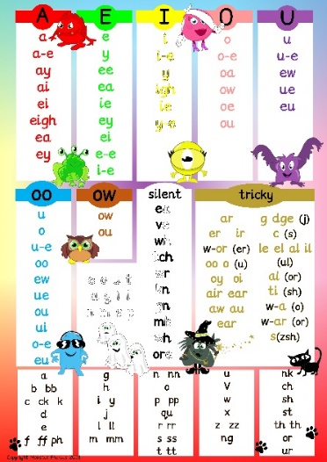

Sounds Poster High-Frequency Words Poster Tricky Words Poster

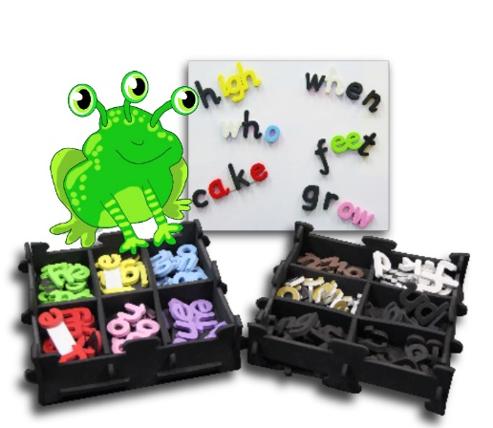
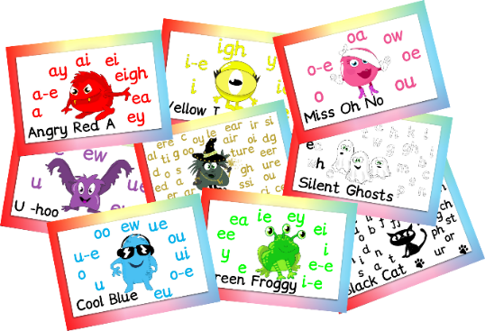
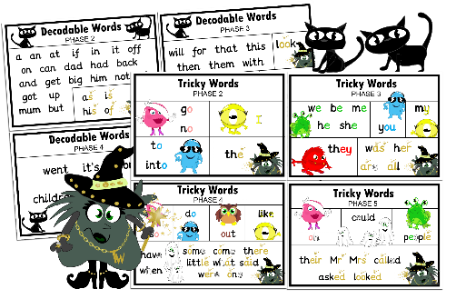

Set of 10 A4 Sounds Posters Magnetic Letter Kits Tricky and Decodable
Letters & Sounds Cards

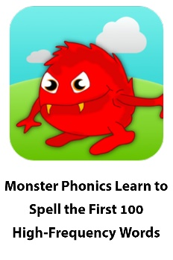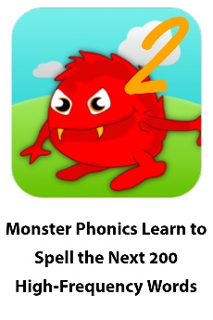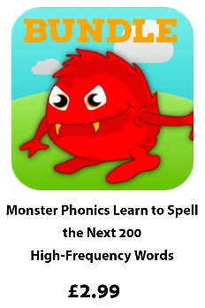

Free resources for parents
Activities
https://monsterphonics.com/free-phonics-worksheets/

Ideas for learning spellings
https://monsterphonics.com/free-resources/fun-ways-to-help-children-learn-phonics-spelling/

Games
https://monsterphonics.com/games/

Flashcards
https://monsterphonics.com/flashcards-2/

Information about phonics
https://monsterphonics.com/how-it-works/letters-and-sounds/
https://monsterphonics.com/how-it-works/ks1-spelling-curriculum/
https://monsterphonics.com/the-phonics-screening-check/

