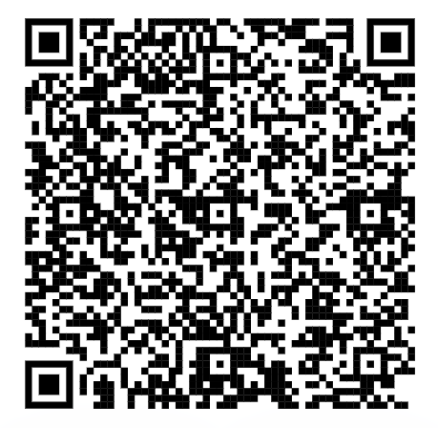
https://mathsbot.com/primary/ks2

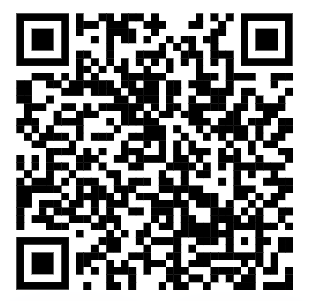
https://myminimaths.co.uk/year-6-mini-maths/

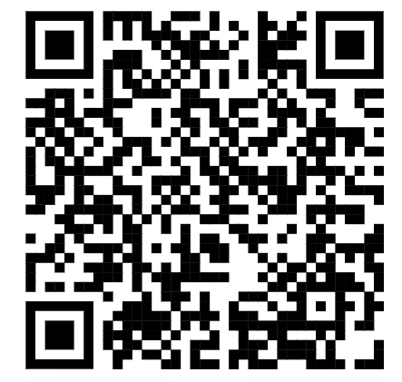
https://corbettmathsprimary.com/5-a-day/
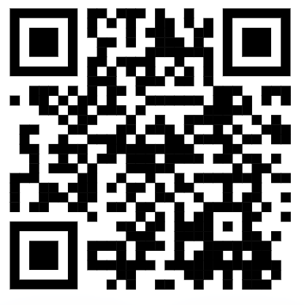
https://readtheory.org/

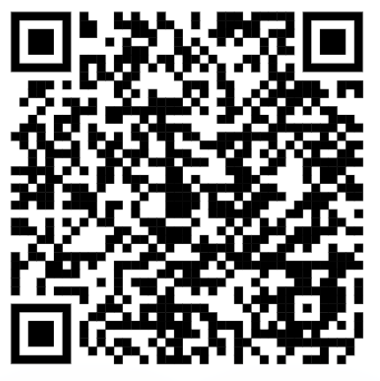
https://home.oxfordowl.co.uk/bookshop/bond-sats-skills/

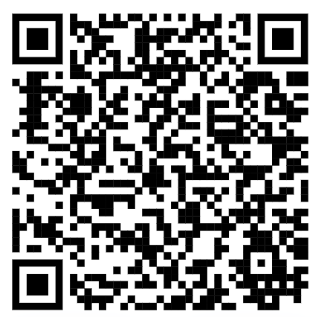
https://www.bbc.co.uk/bitesize/articles/zrybvk7

