Home Learning Cards – Set 1 Activity 1
Fine Motor Threading
Key skills this activity will support your child to develop: fine motor skills, hand-eye co-ordination, perseverance, concentration, reasoning
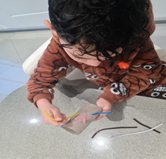  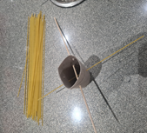 | How to:  Invite your child to help you gather the resources you need e.g. spaghetti and a kitchen roll tube (see below for how to make holes):  - Explain that you are going to do some threading together. Show your child how to push the spaghetti sticks through the tube carefully so they come out the other side, making sure that they don’t snap!  - Encourage your child to do this independently.  - Choose a range of materials to pass through the holes – string, pipe cleaners, straws, cable ties.  - Talk to your child as they thread, asking questions, such as ‘Which objects went through easily? Which were harder to thread? How many objects have you threaded through altogether?’
Adaptations:  - Try using objects with larger/smaller holes. Make a chart to show which objects were easier or harder to thread. Talk about why this might be.  - How many sticks/pipe cleaners can you thread through your object?  - Introduce a timer to add challenge e.g. how quickly can your child thread 10 objects?  - Invite your child to decorate the tube before or after the threading activity. | Resources:  - Kitchen roll tube with holes around it, made by the adult. Use a screw driver, bradawl or pen to do this. Or use a colander, sieve or any household object with multiple holes.  - Spaghetti sticks, pipe cleaners. string or wool and a plastic child-friendly sewing needle, straws, cable ties.  - Timer (egg timer or use a mobile phone)

Top Tip: If using a tube roll, the adult should create the holes in the tube before starting the activities
Home Learning Cards Set 1: Card 1 of 12

