Home Learning Cards– Set 1 Activity 2
Shape Hunt
Key skills this activity will support your child to develop: shape recognition, observation, mathematical vocabulary, reasoning, problem-solving
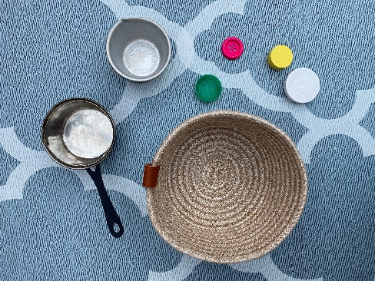  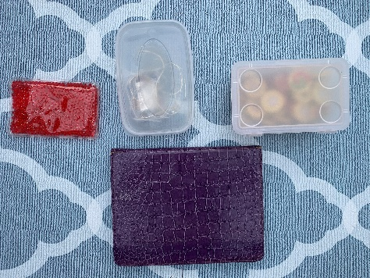 | How to:  - Talk to your child about shapes (2D - flat shapes, 3D – solid shapes). Can they name any shapes?  - Invite your child to help you draw some of the 2D shapes they know or draw some for them.  - Suggest that you both go on a shape hunt around your home to find some of the 2D and 3D shapes you have been talking about e.g. window, face of a clock.  - Talk about the shapes that you have found. Ask your child to talk about what they notice. Can they describe the shapes? Can they spot things that are similar or different?  - Ask your child if there are ways that you could sort the shapes? E.g. by their shape, colour, size or maybe the material they are made from? Talk about the decisions your child makes.  NB: This activity can be started by an adult and then the child can independently collect the items.
Adaptations:  - For younger children you may wish to collect a selection of items and invite your child to sort them into groups.  - Draw around the shapes to make pictures of patterns.  - When you are out for a walk, invite your child to find shapes in the environment. | Resources:  - Items from around the home  - Paper  - Pens/pencils

Top Tip: Support your child to describe the shapes they notice by modelling the correct vocabulary e.g. curves, straight, pointy, corner, edge, face. Remember, 2D shapes are flat shapes that can’t be picked up!
Home Learning Cards Set 1: Card 2 of 12

