Home Learning Cards – Set 1 Activity 3
Collect a Rainbow
Key skills this activity will support your child to develop: drawing/mark-making, observation, predicting, sequencing, counting, vocabulary, comparison
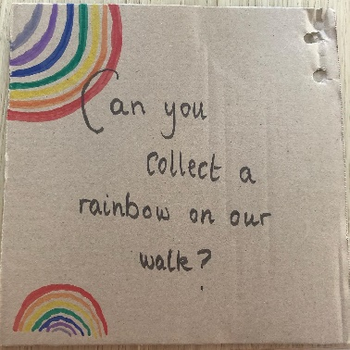  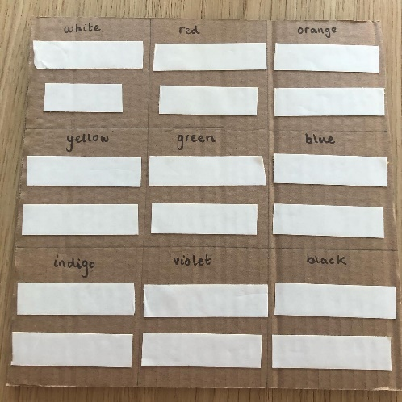 | How to:  - Ask your child to draw a rainbow, using the colours: red, orange, yellow, green, blue, indigo, violet. Discuss this with your child and explain that today, we are going to collect a rainbow!  - Go for a walk with your child and challenge them to spot and collect objects to match each colour of the rainbow.  - Ask your child questions as you walk e.g. Which colour do you think we are going to find the most of? How many red (or blue or green) items have you found so far? What colour do we need next in our sequence?  - Once you have finished your walk, organise your collected objects into a bar graph and see which colour you found most of on your walk.
Adaptations:  - Support your child to create their own nature crown using double sided or sticky tape to stick down the items you have found. Talk to them about the colours and objects that they have found – can they decorate their crown in a pattern? | Resources:  - Paper and a clipboard or card (from the inside of a cereal packet or a section of a thick cardboard box)  - Pens/pencils  - Double-sided tape/sticky tape  - Natural objects found on walk

Top Tip: Remind children that we should only collect flowers from nature and talk about keeping safe e.g. regarding picking up items and washing hands when you return home.
Home Learning Cards Set 1: Card 3 of 12

