Home Learning Cards – Set 1 Activity 4
Den Building
Key skills this activity will support your child to develop: planning, designing, fine motor skills, joining, imagination, problem-solving, vocabulary, writing/mark-making, working together
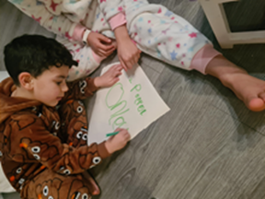  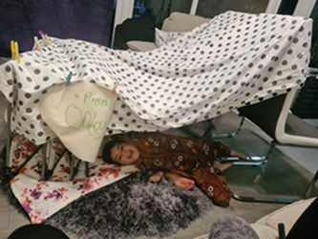 | How to:  - Invite your child to help you make a list of the resources you will need to create your den.  - Encourage your child to help you gather the materials you will use to create the den and tick them off your list as you find them.  - Together, choose an appropriate, clear space to build your den. This could be inside, or outside!  - Encourage your child to think about how the den might look when it’s finished. Discuss the design. Draw and label the design if you like!  - Work together to build the den, encouraging your child to take the lead, thinking about:  * How big does it need to be?  * Where will things go?  * Who is allowed inside?  * Is there enough space to fit everyone inside?  * What will they do inside?  - Support your child to ensure the den is safe to use.
Adaptations:  - Try making a sign to say when the den is open and how many people can go inside.  - Explore using different materials. What happens if we use heavier blankets? How can we make it more comfortable/darker?  - Use your den to create a shop, a playhouse or a cosy reading space. | Resources:  - Large washing basket to gather the resources  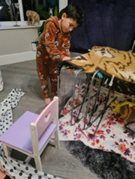  - Blankets, sheets, duvet covers, towels, cushions, pillows  - Clothes pegs  - Chair/clothes horse  - Pens or pencils  - Paper

Top Tip: Provide children with materials free from sharp edges
Home Learning Cards Set 1: Card 4 of 12

