Home Learning Cards – Set 1 Activity 5
Home Cinema
Key skills this activity will support your child to develop: imagination, planning, decision-making, writing/mark-making, designing, vocabulary
  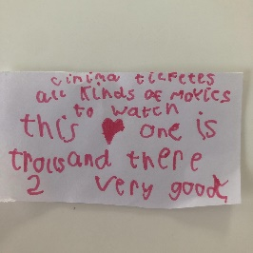  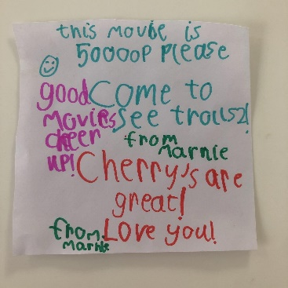 | How to:  - Invite your child to make a role-play home cinema. If your child has been to the cinema before, ask them to share ideas for things you could make and write them on a list. If not, support your child as you make a list of suggestions together e.g., tickets, seating, snacks etc. Tick the ideas on the list as you create them.  - Choose a film that you will watch in your cinema.  - Make signs for your cinema and tickets for your chosen film. Don’t forget to think about how much your ticket will cost! Talk about having different prices for people of different ages.  - Create some advertisements for your film e.g., recorded radio adverts or posters that will let people know when and where it will be shown.  - Write a list for the snacks you might like to eat whilst watching your film, using real-life or pretend food items you might already have at home.  - Create a shop for your customers to ‘buy’ their tickets and snacks. Add prices to the items and use real money or buttons to buy them.
Adaptations:  - Plan and record your own film.  - Put on your own show e.g. a play or a puppet show.  - Support your child to talk about things they liked about the movie after watching it and write a ‘film review’. | Resources:  - Paper and card  - Pens or pencils  - Play or real money/snacks  - DVDs, film streaming services  - Cushions or chairs

Top Tip: You could find film trailers online to play to your child before watching your feature length film!
Home Learning Cards Set 1: Card 5 of 12

