Home Learning Cards – Set 1 Activity 6
Home Snow Recipe
Key skills this activity will support your child to develop: vocabulary, noticing changes, observation, following instructions, fine motor skills, measuring
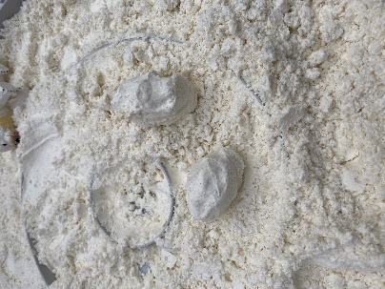  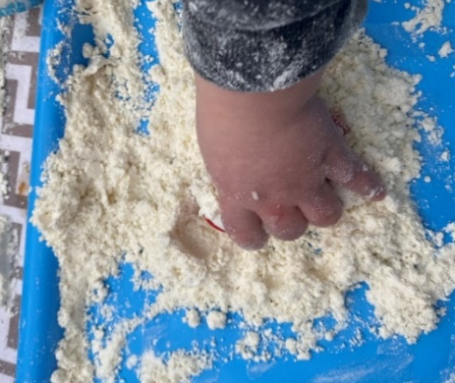 | How to:  - Invite your child to help you to make a list of the ingredients you will need to make your own snow (see below).  - Encourage your child to help you gather the ingredients and tick them off on the list as you collect them.  To make the snow:  - Add 3 cups of flour* and 3 cups of cornflour* to a large bowl and mix together. Gradually add the sunflower oil and mix. As you stir, the mixture will slowly ‘come together’.  - The mixture is ready to use when you are able to make small ‘snowballs’ from it.  - Talk to your child about what you are doing and the changes that are happening as you create the ‘snow’ together. Model vocabulary such as, soft, wet, sticky, fluffy, crumbly, squeeze, roll, mix, pour.  *Please refer to guidance from the Food Standards Agency (FSA) around handling flour and flour products safely before using with your child.  Make sure to:  - wash hands thoroughly with soap and warm water before and after handling flour.  - clean all surfaces properly after contact with flour - wash bowls, utensils, and surfaces with warm, soapy water or your usual surface cleaner and disinfect where necessary.
Adaptations:  - Use food colouring to dye the snow to make it other colours.  - This makes quite a lot of ‘snow’ reduce the numbers of cups if you only want a small amount.  - Consider using gluten free flour* if your child has an allergy. | Resources:  Utensils:  - Large bowl  - Mixing spoon  Ingredients:  - 3 cups of flour*  - 3 cups of cornflour*  - A little sunflower oil

Top Tip: The ‘snow’ can be stored for up to a week in an airtight container. Take a look at Home Learning Cards 9 and 12 to find other ways to use the ‘snow’ with your child.
Home Learning Cards Set 1: Card 6 of 12

