Home Learning Cards – Set 1 Activity 7
Find Some Sticks
Key skills this activity will support your child to develop: observation, vocabulary, problem-solving, reasoning, planning and designing, reading, making up narratives, measuring
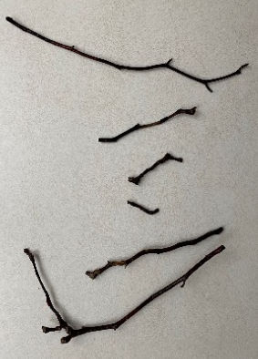  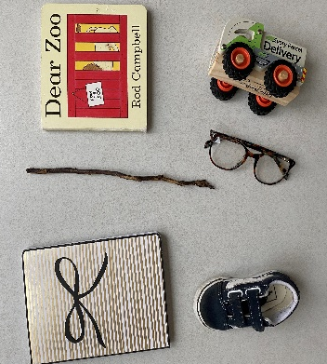  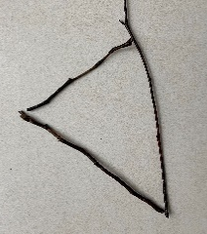 | How to:  - Invite your child to join you on a walk around the garden or local area and explain that today you are going on a ‘Stick Hunt’ to collect sticks.  - During your walk, talk to your child about things that you see, hear, smell and feel in the natural world. Ask your child what they notice.  - Model vocabulary to describe the sticks as you collect them, such as long, thin, bumpy, curved, thick, short etc.  - When you return from your walk, talk with your child about things you could do with the sticks. For example:  - Make a 2D shape using your sticks e.g. a square, a triangle, a rectangle  - Find 5 things longer or shorter than your stick  - Sort your sticks. Can the adult guess the sorting rule the child has used e.g., bumpy sticks, thin sticks, thick sticks, straight sticks, curved sticks?  - Use sticks to measure how deep a puddle is.  - Make a stick den for your favourite cuddly toy.  - Read or watch the story ‘Stick Man’ by Julia Donaldson - Can you make your own stick person or stick animal and retell or make up your own story?  - Remind your child to wash their hands after working with the sticks.
Adaptations:  - Measure your sticks using a tape measure, ruler or items you have at home, such as pasta or buttons.  - Order your sticks from shortest to longest | Resources:  - A bag to collect sticks  - Sticks of varying shapes and sizes  - Stick Man story – book or digital version  - A cuddly toy

Top Tip: Use a container such as a ‘curly crisp’ tube to carry/store your sticks
Home Learning Cards Set 1: Card 7 of 12

