Home Learning Cards – Set 1 Activity 8
Rainbow Cakes
Key skills this activity will support your child to develop: following instructions, fine motor skills, noticing changes, describing, independence, vocabulary
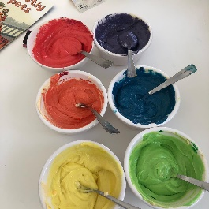  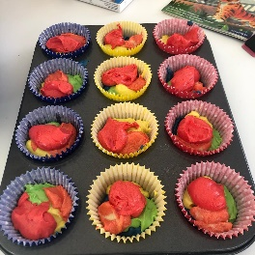  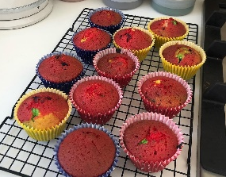 | How to: *Please refer to guidance from the Food Standards Agency (FSA) around handling flour and flour products safely before using with your child.  - Encourage your child to help you gather the utensils and ingredients you will need to make the cakes (see below). Ask your child to wash their hands with you before cooking.  - Place cake cases in a bun tin and pre-heat your oven to 180ºC/Gas 4.  - Weigh the four eggs - the weight they are will be will be the weight needed of the butter, sugar and flour e.g., if the eggs weigh 235g, then you’ll weigh out 235g each of butter, sugar and flour.  - Pour the butter and sugar into a large bowl and beat with a spoon or an electric whisk until light and fluffy.  - Add the eggs and vanilla essence and mix.  - Add the flour and fold it into the mixture.  - Divide the mixture evenly into separate bowls (this will depend on how many colours you have)  - Add a different colours of food colouring to the mixture in each bowl and mix.  - Spoon small scoops of each coloured mixture into each of the cake cases.  - Remind your child to wash their hands thoroughly after handling the raw ingredients and before eating.  - Bake for 15-20 minutes until cooked and leave to cool before eating.
Adaptations:  - You can also make this into a large cake. If you’re making a sandwich cake it will need cooking for 20-25 min and sandwiching together with buttercream  - Buttercream Recipe  - 600g icing sugar  - 300g butter  - Teaspoon of vanilla essence  - Mix together all ingredients until they form a thick cream and then spread onto your cake once cooled. | Utensils:  - Large bowl  - Mixing spoon/electric whisk  - Bun tin  - Cake cases  - Scales  - Small bowls  - Teaspoons  Ingredients:  - 4 eggs  - Self-raising flour  - Caster sugar  - Vanilla essence  - Margarine/butter  - Food colouring – different colours

Top Tip: Talk to your child throughout the baking process about the changes you notice happening to the ingredients and cake mixture. You will know if the cakes are cooked when you stick a knife into them and it comes out clean with no mixture on it.
Home Learning Cards Set 1: Card 8 of 12

