Home Learning Cards – Set 1 Activity 9
Snowy Small World Play
Key skills this activity will support your child to develop: writing/mark-making, vocabulary, noticing changes, observation, following instruction, designing, thinking of ideas, imagination
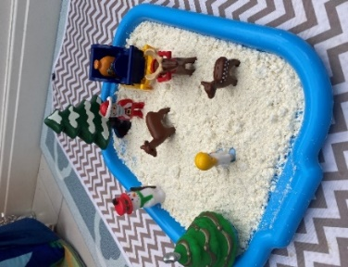  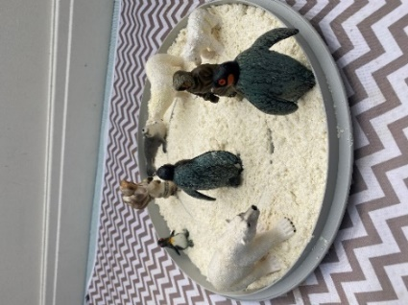 | How to: Support your child to create ‘snow’, using the ‘Home Snow Recipe’ (Home Learning Card 6)*.  - Pour your snow onto a tray or spread it out in a large space.  - Look at non-fiction books or on the internet to talk to your child about the different animals that live in snowy places e.g. polar bears, penguins, walruses. Share your own experiences/memories of snow and encourage your child to do the same, such as building a snowman in the garden.  - Use your own small world characters from home, or support your child to make their own people or animals using paper or card.  - Play alongside your child, making up stories or acting out previous experiences.  - Invite your child to collect objects from the natural world or around the home to create other props to support their imaginative play e.g. a den for the animals to live in, a pool to swim in, ice bergs and mountains etc.  *Please refer to guidance from the Food Standards Agency (FSA) around handling flour and flour products safely before using with your child.  Make sure to:  - wash hands thoroughly with soap and warm water before and after handling flour.  - clean all surfaces properly after contact with flour - wash bowls, utensils, and surfaces with warm, soapy water or your usual surface cleaner and disinfect where necessary.
Adaptations:  - Use food colouring to dye your ‘snow’ different colours - it could become soil, mud, sand or water!  - After joining your child’s play, offer to write out the story they create so you can read it together at bedtime. | Resources:  - A large tray  - “Snow” (see Home Learning Card 6 for recipe)  - Small world animals or characters  - Paper or card  - Natural materials/items found around the home

Top Tip: See Home Learning Card 6 for the ‘Home Snow Recipe’. ‘Snow’ can be stored for up to a week in an airtight container. Make sure your child washes their hands thoroughly after making/handling the snow.
Home Learning Cards Set 1: Card 9 of 12

