Home Learning Cards – Set 1 Activity 10
Make Your Own Musical Instruments
Key skills this activity will support your child to develop: planning, designing, fine motor skills, sound discrimination, describing, following instructions, pattern making, rhythm, singing
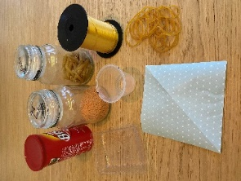  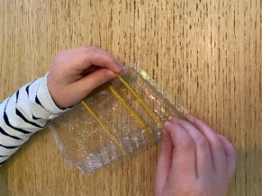  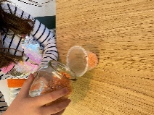 | How to:  - Invite your child to make their own orchestra. Decide what instruments you would like to make e.g. a shaker, a drum or a guitar and make a list of the things you will need to collect (see below).  - To make a shaker: place a small amount of dried pasta, rice or lentils into a pot. Cover the top with a sheet of paper, foil or cling film and secure firmly with an elastic band, tape or string.  - To make a drum: collect a number of different containers and tap with a beater e.g. a wooden spoon, paint brush or stick. Talk about the different sounds that each beater/container makes.  - To make a guitar: find an empty tissue box or biscuit tray. Stretch elastic bands across the packaging. Different widths of band will make different sounds when plucked.  - To make a pasta shaker: thread pasta tubes onto string. Tie the ends together and shake!  - Once you have created your instruments, have fun with your child exploring and talking about the different sounds that they make.  - Sing some of your favourite songs together and encourage your child to use the instruments to play along in time to the beat – you could even try to compose your own piece of music or make up your own songs!
Adaptations:  - Make a band using other items from around the house e.g. pots and pans.  - Try tapping out repeated patterns and rhythms with your instruments. | Resources:  - Dried food items (rice/lentils/pasta) – see alternatives below.  - Clean, empty food packaging and boxes.  - Elastic bands/tape/string.  - Paper/foil/cling film.  - Wooden spoons, paint brushes or sticks.

Top Tip: Stretching elastic bands across a box is a great way to develop fine motor skills! If you don’t have any dried food items to spare, try using other small objects you might have to hand e.g. buttons, gravel, beads etc.
Home Learning Cards Set 1: Card 10 of 12

