Home Learning Cards – Set 1 Activity 11
Grow Your Own Vegetable Tops
Key skills this activity will support your child to develop: independence, fine motor skills, writing/labelling, predicting, explaining, vocabulary, observation, noticing changes, comparison
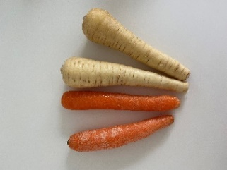  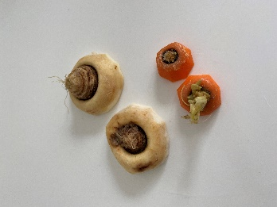  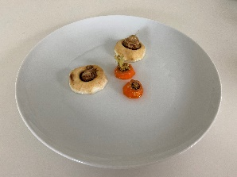 | How to:  - Gather together some root vegetables such as parsnips, carrots, beetroot or turnips. Invite your child to help you to carefully cut the tops off of the vegetables.  - Place the vegetable tops on a saucer or small plate.  - Support your child to write labels for each of your vegetable tops, to remind you of the vegetables you are growing.  - Add a small amount of water to the saucer or plate - just enough for the ‘tops’ to have a drink.  - Talk to your child about the best sunny spot to place your tops in your home, such as on a windowsill.  - Top up the water daily to make sure the ‘tops’ do not dry out.  - Keep watching the ‘tops’ for a few days and talk about what you can see happening to them.  - Support your child to keep a diary of your vegetable tops and record the changes daily. This could be done by supporting your child to write or draw the changes that they notice.
Adaptations:  - Place your tops in different environments to experiment where they will grow best. For example, what happens if you don’t water some of them, or see what happens if you leave some in a dark cupboard or on a plate above a radiator? | Resources:  - Discarded root vegetables e.g. parsnip, carrot, turnip, beetroot  - Plate/saucer  - Water  - Knife  - Paper

Top Tip: Wait until you are using the vegetables in your home cooking – you only need the discarded tops for this activity, so the rest of the vegetable can be used in your meals!
Home Learning Cards Set 1: Card 11 of 12

