Home Learning Cards – Set 1 Activity 12
Mark-Making in ‘Snow’
Key skills this activity will support your child to develop: writing/mark-making, fine motor skills, vocabulary, noticing changes, observation, following instructions
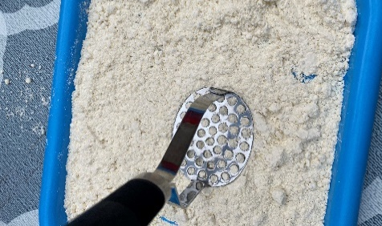  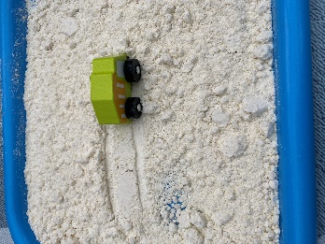 | How to: Support your child to create ‘snow’ using the ‘Home Snow Recipe’ (Home Learning Card 6)*.  - Pour the ‘snow’ into a tray or large space outdoors. Encourage your child to use their fingers to make some marks in the snow.  - Find other objects around the home to make marks in the snow e.g. lolly sticks, forks, wooden or metal utensils or even some cars. Talk to your child about the marks that different objects make.  - Encourage your child to make patterns in the ‘snow’ such as zig-zags, wiggly lines, or lots of straight lines.  - Use utensils to draw pictures in the snow, such as faces, animals or transport – you could make this into a game by trying to guess what each person is drawing.  - If your child is able to, practise writing in the ‘snow’, such as their name or some letter shapes.  *Please refer to guidance from the Food Standards Agency (FSA) around handling flour and flour products safely before using with your child.  Make sure to:  - wash hands thoroughly with soap and warm water before and after handling flour.  - clean all surfaces properly after contact with flour - wash bowls, utensils, and surfaces with warm, soapy water or your usual surface cleaner and disinfect where necessary.
Adaptations:  - Say some letter sounds (phonemes) and challenge your child to write the letter shape (graphemes) in the ‘snow’  - Support your child to write other names or words they know e.g. family members, pets or friends | Resources:  - Tray  - ‘Snow’ – see recipe on Home Learning Card 6  - Lolly sticks  - Toys  - Household items

Top Tip: See Home Learning Card 6 for the ‘Home Snow Recipe’. ‘Snow’ can be stored for up to a week in an airtight container. Make sure your child washes their hands thoroughly after making/handling the snow.
Home Learning Cards Set 1: Card 12 of 12

