Home Learning Cards – Set 2 Activity 1
Indoor Mini Golf
Key skills this activity will support your child to develop: fine motor skills, gross motor skills, thinking of ideas, perseverance, concentration, counting
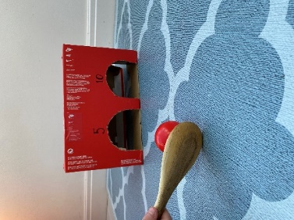  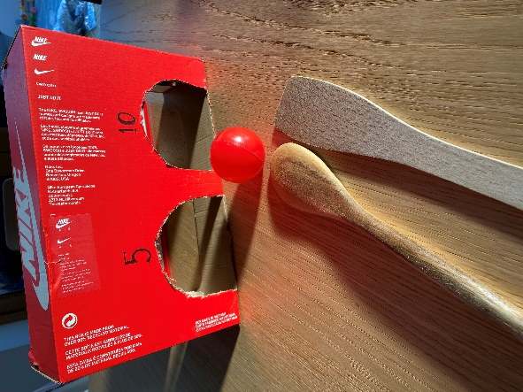 | How to:  - Invite your child to join you in a game of mini golf! If you child has played mini golf before, talk to them about the things they used that you will need to create e.g. clubs, balls, holes etc. If this is a first experience of golf for your child, you could show them pictures or videos on the internet to support their understanding.  - Support your child to make a list of items that you will need and tick them off as you collect them.  - Gather together a variety of boxes and tubes. Support your child to cut holes into the boxes that a large enough for a ball to fit through.  - Together, label each hole with a number. The numbers could be the order in which you must complete the course, or your score for getting your ball through that hole.  - Find a floor space large enough to become your ‘golf course’ and set up your ‘holes’.  - Using a long tube, wooden spoon or spatula as a club, see if you can tap your ball into the boxes. Count how many turns it takes to get your ball into each hole.  - Create a tally chart to note down the scores for each hole. Support your child to count them altogether at the end of the game to total the scores.
Adaptations:  - How many can you score in 30 seconds? Set a family challenge.  - Increase difficulty levels by changing the size of the ball, spoon or hole. | Resources:  - Old boxes  - Scissors  - Felt pen/markers and paper  - Wooden spoon, spatula or long tube  - Ball – see top tip below!

Top Tip: If you don’t have a ball available, try rolling up a pair of socks or taping together some scrunched up paper to create your own! On a nice day, why not take your mini golf set outside?
Home Learning Cards Set 2: Card 1 of 14

