Home Learning Cards – Set 2 Activity 2
Puppet Theatre
Key skills this activity will support your child to develop: fine motor skills, planning, designing, decision making, writing/mark-making, drawing, imagination, listening, re-telling, performing
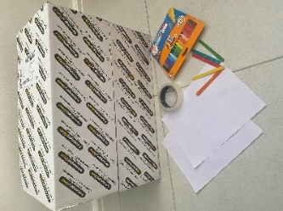  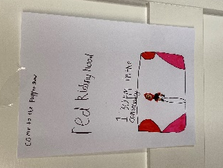  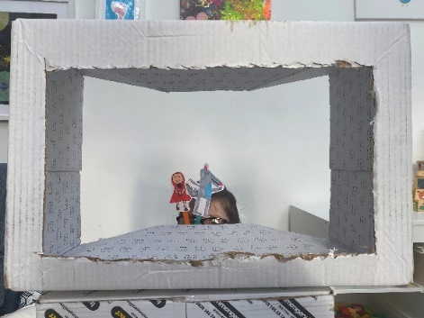 | How to:  - Invite your child to help you make the puppet theatre – you could show them what this looks like on the internet if they haven’t seen one before.  - Together, choose a suitable large box and cut a ‘frame’ shape out of the front, to create a ‘stage’ (see photo: bottom left). The adult will need to support the cutting of the card.  - Decide on the show you would like to act out in your puppet theatre – this could be a favourite story, or one that you could make up with your child!  - Create your puppets. The characters could be drawn on paper, coloured and cut out. To make the puppets firmer, they could be stuck onto card and then cut out.  - Stick your characters onto lolly sticks or strips of card to create a ‘handle’.  - Make some posters to advertise your puppet show and create tickets for your show.  - Practice your puppet show and then enjoy performing to your family!
Adaptations:  - Create scenery for your show on paper that can be swapped in between scenes.  - If you don’t have a large box, a sheet of cardboard cut into a frame shape works just as well . | Resources:  - Old box/paper and card  - Lolly sticks  - Sticky tape  - Scissors  - Felt pens/pencils

Top Tip: Use books from home or the library to help your child to decide which story they would like to act out and the characters/scenery that they will need to make. Once you have performed your show, why not record it on a digital device – you could send it to other members of your family, or email it into school to share with your teachers and friends!
Home Learning Cards Set 2: Card 2 of 14

