Home Learning Cards – Set 2 Activity 3
Scavenger Hunt
Key skills this activity will support your child to develop: concentration, reading, counting, observation, noticing, explaining,
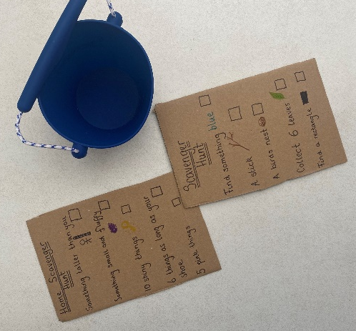 | How to:  - Set up the scavenger hunt in preparation for this activity – it could take place either indoors or outside.  - Plan things you might find and note them on a ‘scavenger list’ e.g., find something red, something that tells the time, collect 5 things that are soft.  - Talk through the scavenger list with your child and challenge them to join you on your scavenger hunt. During the hunt, talk to your child about where they found each item. You could ask questions such as, “What do we need to find next? Where do you think we might find that?”  - Take a bucket or large pot to collect some of the items you find. Some items may be collected, while others will need to just be ‘seen’ e.g. a tall tree, traffic lights or a tap. (You could use a device to support your child to take photographs of things that can’t be collected).  - After your hunt, talk about the things you have found. Were any harder to find than others? Did you find everything?
Adaptations:  - Introduce a timer. Can you collect/find all items before the timer runs out?  - Challenge your child to plan and create their own scavenger hunt and list for a friend or family member. | Resources:  - cardboard  - pens/markers  - clipboard  - bucket or pot  - paper

Top Tip: Using a thick sheet of cardboard for your scavenger list means that you have a nice firm surface to work on, almost like a clipboard!
Home Learning Cards Set 2: Card 3 of 14

