Home Learning Cards – Set 2 Activity 4
Sending Special News
Key skills this activity will support your child to develop: vocabulary, explaining, recalling, writing/mark-making, drawing, reading, following instructions
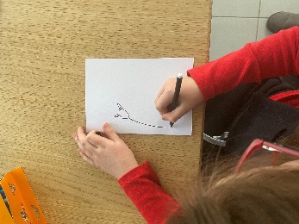  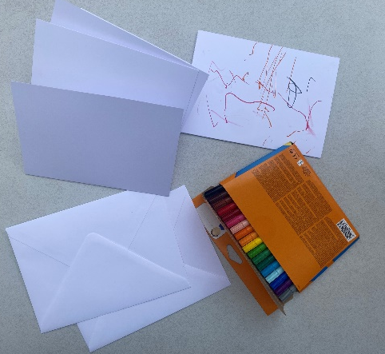 | How to:  - Talk to your child about something special or fun that has happened to them recently – perhaps a special day spent with family or something fun they did at school.  - Talk about important people in your child’s lives and ask who they would like to tell their special news to – this could be a friend, a family member or a teacher at school or nursery.  - Ask your child how they would like to share their news – perhaps they could write a message or draw a picture. You can support your child by talking about the marks they make, helping them to listen for and write the sounds in words, or scribing what they say beneath their picture.  - Once they have created their message, place it in an envelope. Talk to your child about the information needed on the front to ensure it gets to the right place. Write on the envelope with your child or support them to do this independently if they are able to.  - Decide how you are going to get the message to the chosen person – you could post it in a post box or deliver it to their front door (if you need a stamp, you could go together to buy one from the post office).  - Support your child to create a map of the route to the post box or the chosen person’s home. Talk about the things you might see along the way and the directions you will need to take.  - Take your child to deliver their special message – don’t forget to take your map so that you can follow it along the way!
Adaptations:  - To develop scissor skills, why not create a collage instead of a drawing? | Resources:  - Card/paper and pens  - Envelope  - Stamp

Top Tip: Use photographs of special events or people to help your child decide what they would like to include in their message and who they would like to send it to.
Home Learning Cards Set 2: Card 4 of 14

