Home Learning Cards – Set 2 Activity 5
Coin Sort
Key skills this activity will support your child to develop: observing, noticing, describing, reasoning, sorting, matching, counting, problem-solving
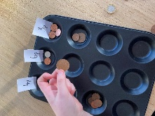  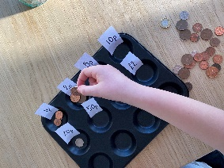  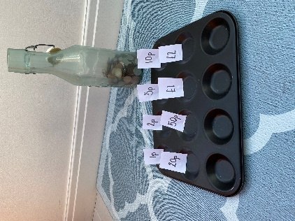 | How to:  - Invite your child to help you to sort out some loose coins. You might like to choose one or two coin values to sort at first e.g. 1p and 2p and then build up to using more as your child gains confidence.  - Label a bun tin with the numbers that match your coins e.g., 1p, 2p, 5p, 10p, 20p  - Look at the coins you are sorting with your child. Talk about how you know which coin is which e.g., by looking closely at the pictures and numbers that are written on them. Model vocabulary to describe each coin’s shape, size and colour e.g. round, silver, small, large, bronze etc  - Ask your child to select a coin, look at it closely and then place it in the correct space in the bun tin. Your child can then continue until all coins are in the correct spaces in the bun tin.  - Count the coins in each space in the bun tin – support your child to make a tally chart to help them to count how many of each coin they have. Talk about what you notice and ask your child questions e.g. are the amounts more, fewer or equal? Which coin do you have most/least of?  - To challenge your child, you could label the bun tin with amounts that would need more than one coin e.g. 6p or 3p. Challenge your child to add coins to the correct value.
Adaptations:  - Draw spots on the labels to help you child make connections to the numeral and the amount it represents e.g., 2 spots for 2p.  - Choose different ways to sort the coins, e.g. colour or shape. | Resources:  - Bun tin/plates/pots/bowls  - Coins  - Paper labels  - Pen or pencil

Top Tip: If you don’t have a bun tin, small pots/bowls/plates work just as well! Using real money allows children to get used to the variations in coins for when they use them in real life situations
Home Learning Cards Set 2: Card 5 of 14

