Home Learning Cards – Set 2 Activity 6
Playdough Recipe
Key skills this activity will support your child to develop: fine motor skills, following instructions, independence, describing, vocabulary, noticing changes, observation
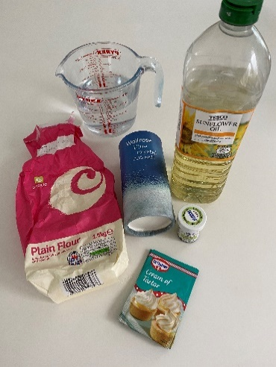  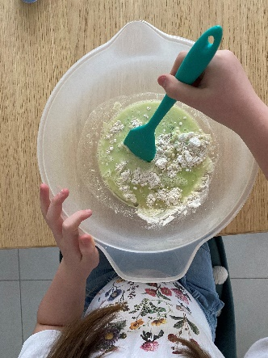 | *Please refer to guidance from the Food Standards Agency (FSA) around handling flour and flour products safely before using with your child.  Make sure to:  - wash hands thoroughly with soap and warm water before and after handling flour.  - clean all surfaces properly after contact with flour - wash bowls, utensils, and surfaces with warm, soapy water or your usual surface cleaner and disinfect where necessary.  How to:  - Ask your child to help you gather all of the ingredients and utensils needed to make playdough.  - Place the dry ingredients (see below) into your large microwaveable bowl and mix together.  - Add the food colouring to your cup of water then add this to the dry mixture. Next, add the oil and stir your mixture well.  - Place the bowl into a microwave for 1 minute. Take it out and stir the mixture. Return it to the microwave and heat again, checking every 30 seconds until the dough is firmer to touch.  - Once the mixture has formed a firm dough, turn it out onto a lightly floured surface. BE CAREFUL at this point as the dough will be hot. Leave to cool for around 5 minutes.  - Once your dough is cool, ask your child to knead the dough to make it soft and smooth. If your dough is sticky, add a little more flour. If your dough is too dry, add a little more oil. Your dough is now ready to be used!  - Why not support your child to draw pictures or write labels for each step of the recipe – you can use this the next time you make playdough or share with a friend.
Adaptations:  - This can also be made on the hob – transfer the ingredients into a saucepan and cook on a low/medium heat, stirring constantly.  - Add scents to the playdough mix for a different experience, such as vanilla essence or cinnamon. | Utensils  - Microwaveable bowl, spoon, cup, microwave oven  Ingredients  - 1 cup of flour* (see above)  - 1 cup of water and food colouring  - 1 tablespoon of vegetable oil  - 2 teaspoons of cream of tartar  - ½ a cup of salt  (To make a larger batch, double up the ingredients)

Top Tip: Make sure your child washes their hands thoroughly after handling raw ingredients and before/after exploring the playdough. See Home Learning Card 7 for ideas on how to use your playdough with your child!
Home Learning Cards Set 2: Card 6 of 14

