Home Learning Cards – Set 2 Activity 7
Playdough Pictionary
Key skills this activity will support your child to develop: fine motor skills, following instructions, thinking of ideas, imagination, modelling, concentration, describing, vocabulary, turn-taking
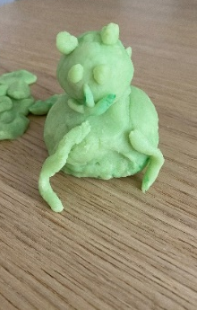  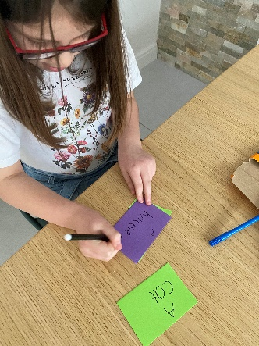 | How to:  - Invite your child to play ‘Playdough Pictionary’ with you. You can play this game with two or more players and will need to a batch of playdough – use our recipe (Home Learning Card 6)*.  - Make a selection of cards naming objects you could make e.g. a cat, a hat, a house etc.  - Place the cards in the middle of the table, face down.  - The first player should select a card and then make a model of the object that is on the card. The other players have to guess the object that is being made - the first person to guess correctly wins a point!  - Make a tally chart to record each player’s score.  - Take turns around the table, making models and guessing what they might be until all of the cards have run out.  - Encourage your child to count the total tally marks for each player and ask who has the most points to decide who the winner is.  *Please refer to guidance from the Food Standards Agency (FSA) around handling flour and flour products safely before using with your child.  Make sure to:  - wash hands thoroughly with soap and warm water before and after handling flour.  - clean all surfaces properly after contact with flour - wash utensils and surfaces with warm, soapy water or surface cleaner and disinfect where necessary.
Adaptations:  - Introduce a timer and make the models against the clock.  - If your child finds reading the words challenging, draw pictures on the cards or have objects hidden in a bag to select and create models of. | Resources:  - playdough  - paper or card  - pens or pencils  - objects from around the house

Top Tip: Store your playdough in an airtight container in the fridge for up to two weeks so that you can re-use it again and again!
Home Learning Cards Set 2: Card 7 of 14

