Home Learning Cards – Set 2 Activity 8
Ice Escape
Key skills this activity will support your child to develop: thinking of ideas, problem-solving, predicting, observation, noticing changes, describing, reasoning, vocabulary, fine motor skills
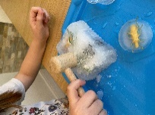  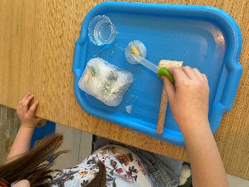  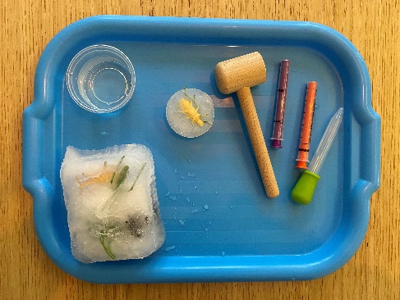 | How to: (You will need to prepare this activity the day before you want to undertake your ‘Ice Escape’.)  - Fill pots with water and add small world people/animals or other small objects, such as buttons, bottle lids etc. Place them in the freezer overnight.  - On the day of your activity: remove the pots from the freezer and show them to your child. Tell them that you need their help to ‘release’ the trapped items from the ice. Ask your child for suggestions on how they might do this. You could suggest methods such as, warm water, vinegar, rubbing the ice or using a small hammer.  - Ask questions such as, which do you think is going to work the fastest/slowest? Are there any that they don’t think will work? Do they have any other suggestions?  - Encourage your child to try out the methods to ‘save’ the trapped objects. Show them how to use a medicine syringe, cotton bud or a teaspoon to slowly add liquids to the ice. Ask your child what they are noticing as they work? Model vocabulary to describe the ice at different stages e.g. freezing, cold, slippery, melting, dripping etc.  - As the ice melts, you could offer your child small tweezers or tongs to remove the objects that are escaping from the ice.
Adaptations:  - Filling a balloon with objects and water then freezing it creates a fun ‘trapped’ world  - On really cold days why not leave outside overnight to freeze! | Resources:  - small objects e.g. characters, buttons etc  - pipette/medicine applicator/cotton buds/teaspoon/toy hammer/tweezers  - freezer  - plastic pots  - water/salt water/vinegar/warm water

Top Tip: Remove the ice from the freezer for 5 – 10 minutes before you use it to avoid ice burn injuries.
Home Learning Cards Set 2: Card 8 of 14

