Home Learning Cards – Set 2 Activity 9
Tally Treasure Hunt
Key skills this activity will support your child to develop: concentration, reading, counting, noticing, explaining, imagination
  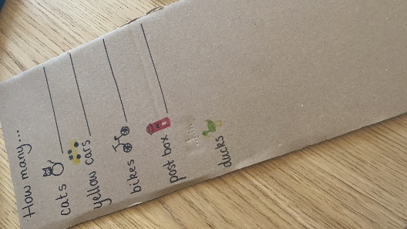  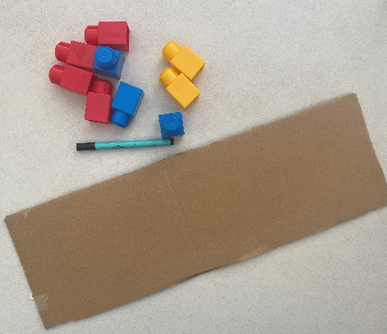 | How to:  - Before the activity: Prepare a ‘treasure hunt list’ with items that you might see on a walk around your home or local area. This could include: door handles, light switches, chairs, pillows (inside) or trees, lamp posts, gates, traffic lights (outside).  - Tell your child that a pirate has lost their treasure and needs their help to find it!  - Show your child the treasure hunt list and explain that you will create a ‘tally’ as you go on your hunt, marking off things as you find them. This could be the five bar gate method (see beside photos) or just making a mark every time you see an item. Teach your child how to do this if they are unsure.  - Go on your treasure hunt. When you have finished, create a representation of what you found using brick towers e.g., if you found 5 cars, make a tower of 5 bricks. Ask your child questions that they can answer by counting the bricks e.g. What did you find most/fewest of? How many more trees did you see than traffic lights?
Adaptations:  - Add pictures alongside the words on your list for those who are not yet reading.  - Challenge your child to create a ‘treasure hunt list’ of their own with words or pictures. | Resources:  - paper  - pens/pencils  - clipboard  - card  - bricks

Top Tip: Use cardboard kitchen towel tubes as binoculars or telescopes to help your child to get into the role of a ‘pirate’. You could even support them to use card or paper to create props, such as a pirate hat or eye patch, to add to the fun!
Home Learning Cards Set 1: Card 9 of 14

