Home Learning Cards – Set 2 Activity 10
Sensory Jelly Play
Key skills this activity will support your child to develop: following instructions, describing, thinking of ideas, planning, designing, imagination, fine motor skills, independence
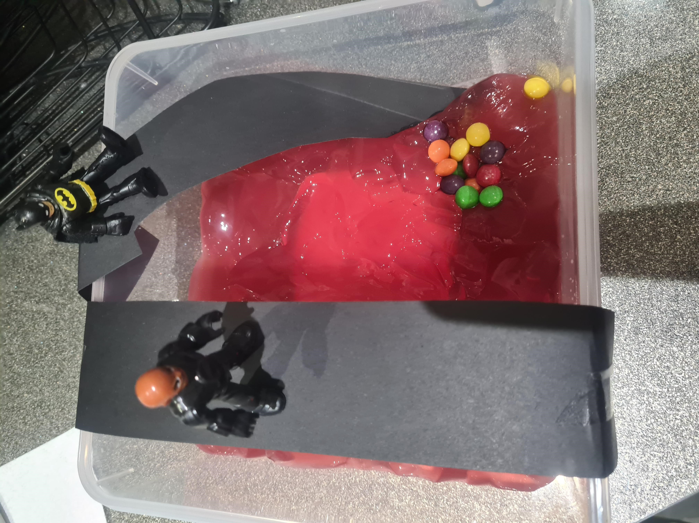  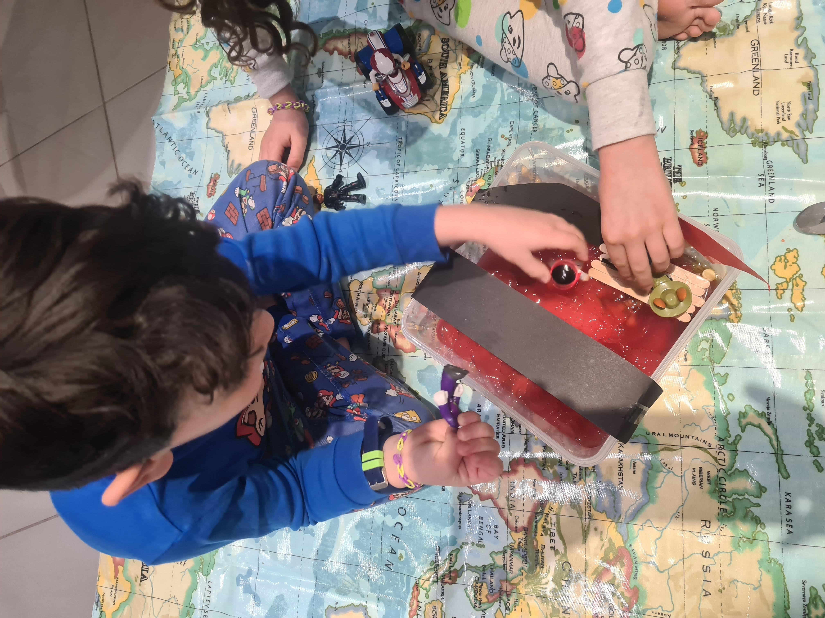  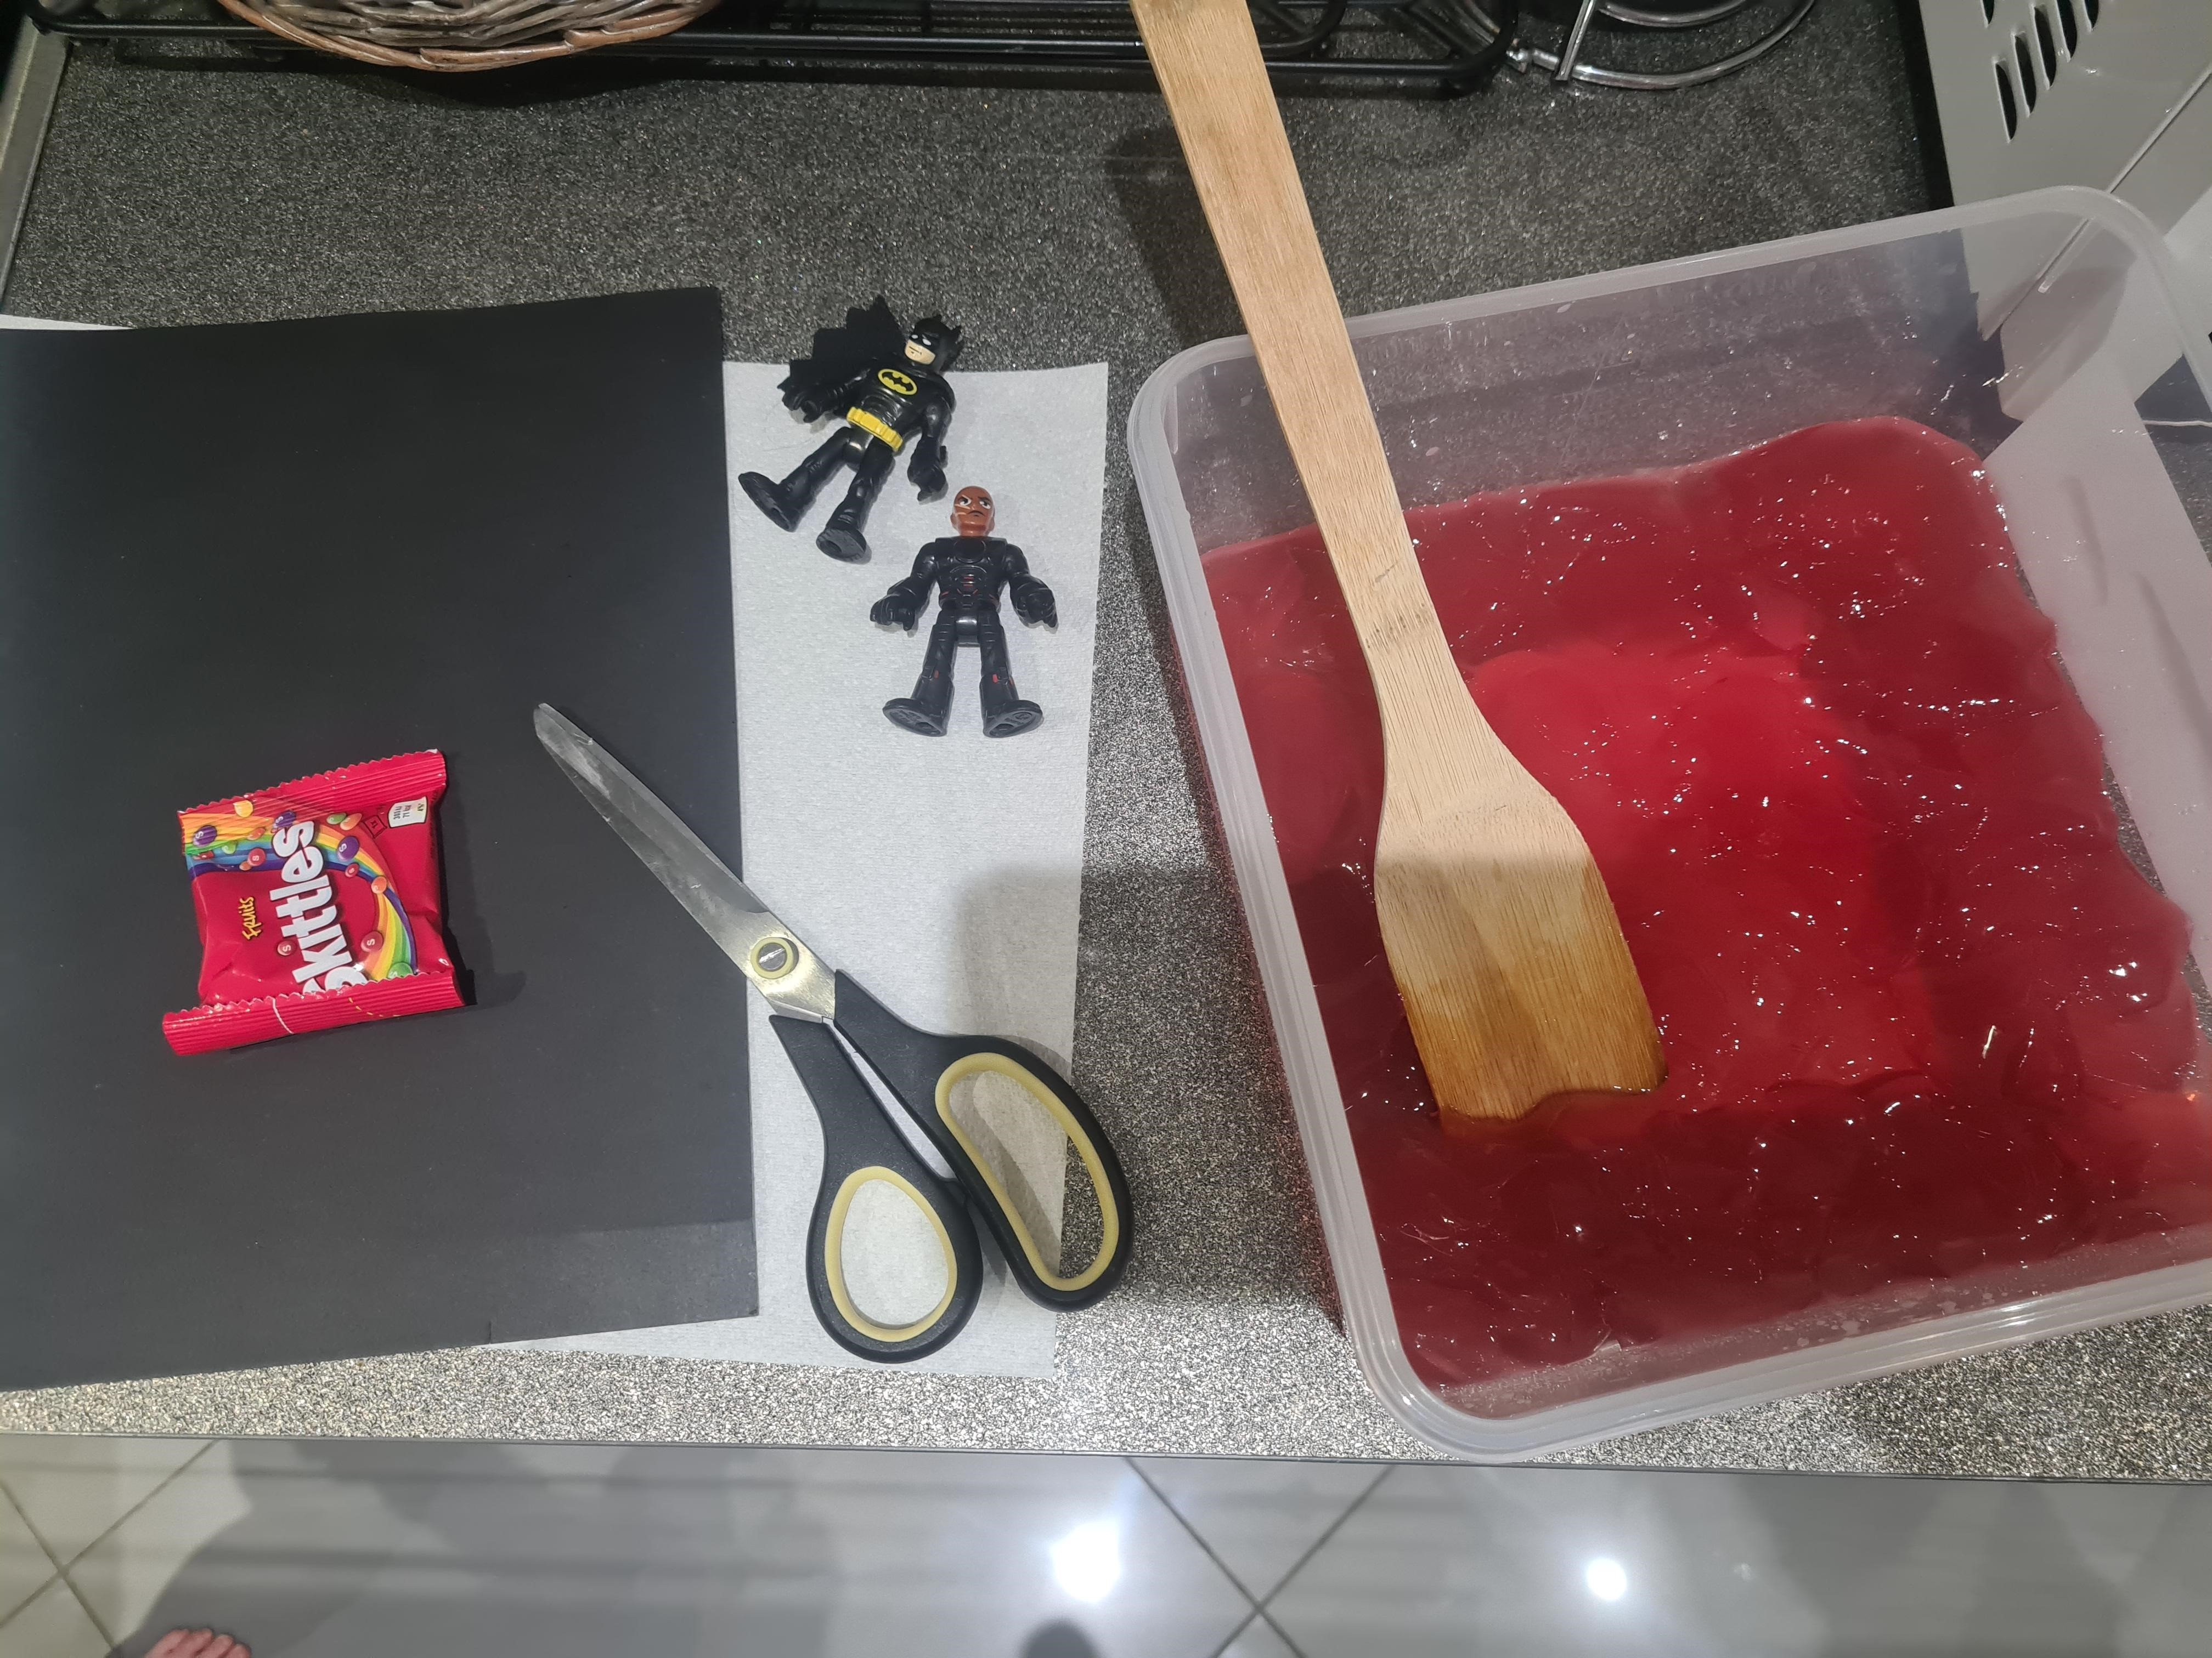 | How to:  - The day before the activity: prepare some jelly with your child and leave it in the fridge to set overnight.  - On the day of the activity: Invite your child to help you prepare for this activity by covering the floor or table with newspaper or a cloth to protect the surface, as this play could get messy!  - Find a suitably large container for the jelly e.g. an empty ice cream tub, small bucket or a washing up bowl.  - Half fill the container with the prepared jelly  - Talk with your child about what characters or scene they might like to create  - Encourage your child to collect some small toys or figures to use to create their chosen scene e.g. small plastic people, toy wild animals, arctic creatures.  - Have fun with your child playing alongside them in their imaginative play.  - To make the scene pictured: Support your child to cut a strip of card/paper and attach to either side of the box to make a bridge using tape/glue  - Using another strip of paper/card, work together to create and attach a slide to go into the jelly mixture.
Adaptations:  - Gelatine-free jelly is available to use for children who are unable to use gelatine.  - Talk to your child about the changes in the jelly when it is heated with hot water or cooled in the fridge. | Resources:  - Jelly  - Newspaper or a plastic sheet  - A container e.g. an ice cream tub  - Scissors  - Sellotape  - Small toys

Top Tip: The melting of the jelly should be undertaken by an adult and observed by the child/children. Encourage your child to help you to clean up after the activity – washing tubs and resources is great for building independence and fine motor skills!
Home Learning Cards Set 2: Card 10 of 14

