Home Learning Cards – Set 2 Activity 11
Jelly Dip
Key skills this activity will support your child to develop: following instructions, fine motor skills, concentration, perseverance
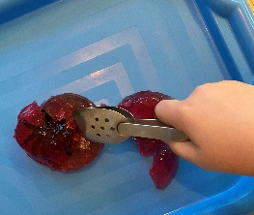  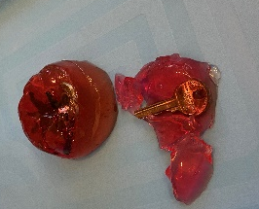  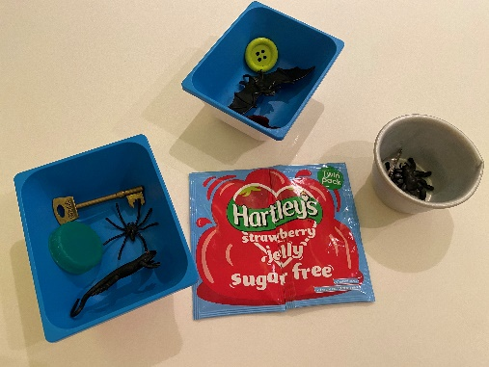 | How to:  - Invite your child to help you to fill small containers/pots with a selection of small items found around the home.  - For extra challenge, add really tiny items for your child to find – it will also make the game last longer!  - Make up the jelly following the instructions on the packet and then pour it into the containers/pots.  - If you are able, leave the jelly in the fridge overnight to ensure that it is fully set.  - When it is set, turn the jelly out onto a tray or plate. You may find it is easier to turn out by running a knife around the container/pot or running the container/pot under a hot tap for a moment to loosen the jelly.  - Pull the small items out of the jelly using tongs or fingers. This will help your child to develop their fine motor skills.
Adaptations:  - Gelatine-free jelly is available to use for children who are unable to use gelatine.  - Use a timer to see how many objects your child can pull out in a certain time limit. Practise counting the items to find the total. | Resources:  - Pots/containers (not too large)  - Tray/plate  - Small items  - Tongs  - Jelly  - Water  - Tweezers or tongs

Top Tip: The melting of the jelly should be undertaken by an adult and observed by the child/children.
Home Learning Cards Set 2: Card 11 of 14

