Home Learning Cards – Set 2 Activity 12
Weekend Wishes
Key skills this activity will support your child to develop: describing, recalling, thinking of ideas, following instructions, writing/mark-making, drawing, vocabulary, making choices
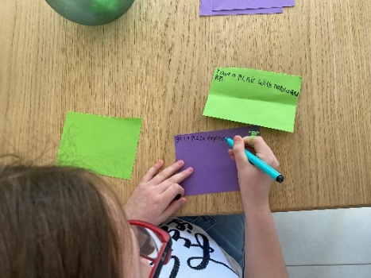  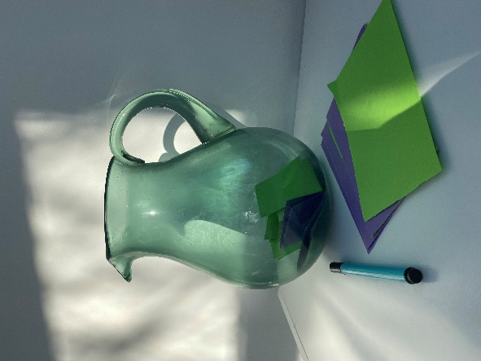 | How to:  - Talk to your child about their favourite things at home and activities they like to do at the weekends.  - Gather the resources needed and explain the ‘Weekend Wishes’ jar to your child. Talk to them about how you will store the weekend wishes and pick one out on the weekends do to together as a family.  - Tell them that you are going to write down your first wish and tell them what that wish is e.g. “Have a teddy bears’ picnic in the garden”, or ‘Go for a bike ride’. Write down your wish on a piece of paper, fold up your wish and place in the jug.  - Invite your child to choose their first wish and support them to write it on a piece of paper, fold it up and place it in the jar. If they are not confident to write independently, they could draw a picture and you could offer to write for them.  - Keep adding wishes as you think of them over time and take one out each weekend to do together as a family.  - After completing each wish, encourage your child to draw a picture of what they did, or write a ‘wish review’. You could hang these up in their bedroom or stick them in a scrap book to remind them of the fun they have had!
Adaptations:  - You could prepare a list of ‘wishes’/activities for your child to choose from.  - Support your child to decorate your ‘wish jar’ | Resources:  - Jug/vase  - Paper  - Pen/pencil

Top Tip: Set aside a time each week to add to the jar and talk about the fun ‘wishes’/activities that have happened each weekend.
Home Learning Cards Set 2: Card 12 of 14

