Home Learning Cards – Set 2 Activity 13
Lacing Necklaces
Key skills this activity will support your child to develop: vocabulary, measuring, fine motor skills, sequencing/pattern making, hand-eye co-ordination, concentration, counting
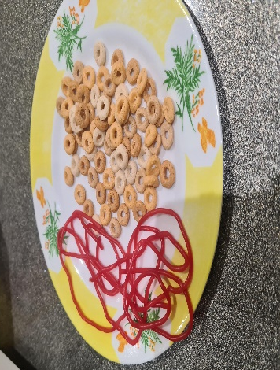  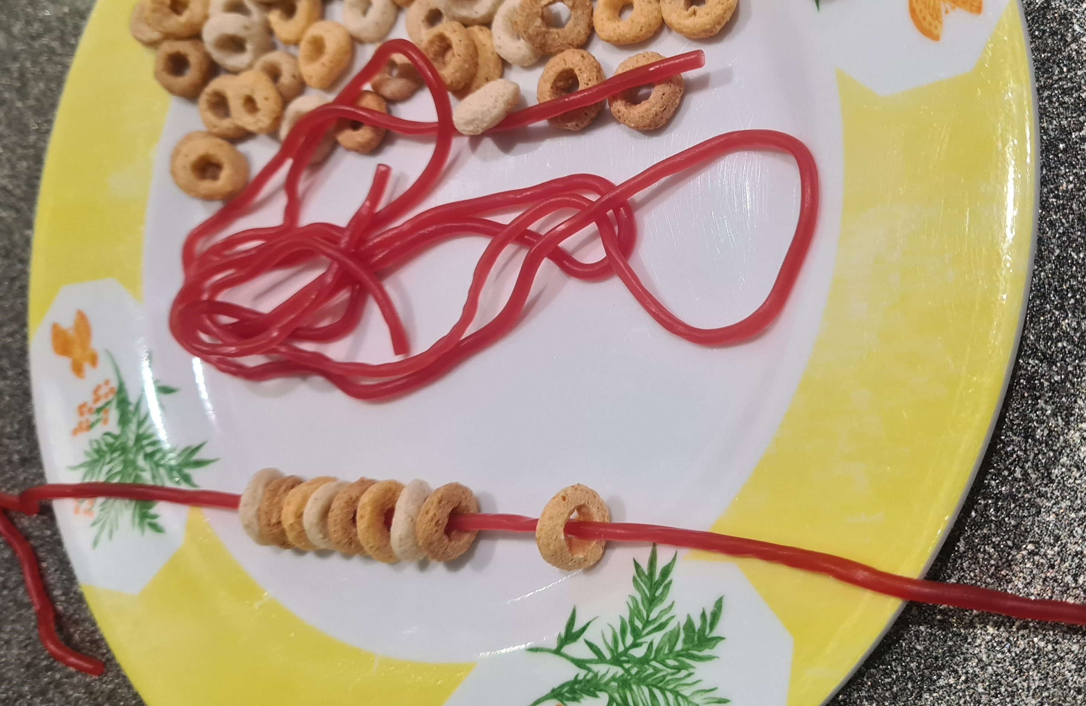 | How to:  - Explain that you are going to do make some necklaces today. Invite your child to help you gather the resources you need (see below).  - For the necklace string, you can use wool, string, pipe cleaners or strawberry lace sweets!  - If using string/wool, support your child to measure and cut the length they want for their necklace. If using laces or pipe cleaners, ask your child to think about ways they could make the necklace longer – you could show them how to tie two together to extend their necklace if needed.  - Provide different items for your child to thread to decorate their necklace and encourage them to do this independently – you could use small beads, multi-hoops or pasta tubes to decorate your necklace string. The smaller, the more challenging!  - Talk to your child as they thread, asking questions, such as ‘What do you need next in your sequence? How do you know? How many more do you think will fit on your necklace? How many objects have you threaded altogether?’  - Challenge your child to create a repeating pattern with the items you have available – you could model this to them first.
Adaptations:  - Introduce a timer and challenge your child to see how many objects they can thread in 1 minute.  - If using pasta, this can be easily dyed with food colouring to create different colours. | You might need:  - String/wool  - Strawberry laces/pipe cleaner/spaghetti  - Multi hoop cereal/beads/pasta tubes

Top Tip: Increase difficulty level by making the beads/hoops smaller and the lace more flexible.
Home Learning Cards Set 2: Card 13 of 14

