Home Learning Cards – Set 2 Activity 14
Word Wizards
Key skills this activity will support your child to develop: phoneme awareness, oral blending, phonic knowledge, reading, rhyme, imagination, fine motor skills,
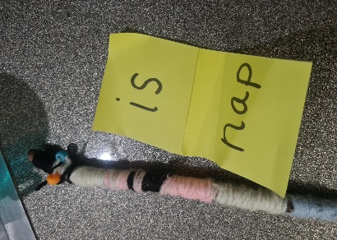  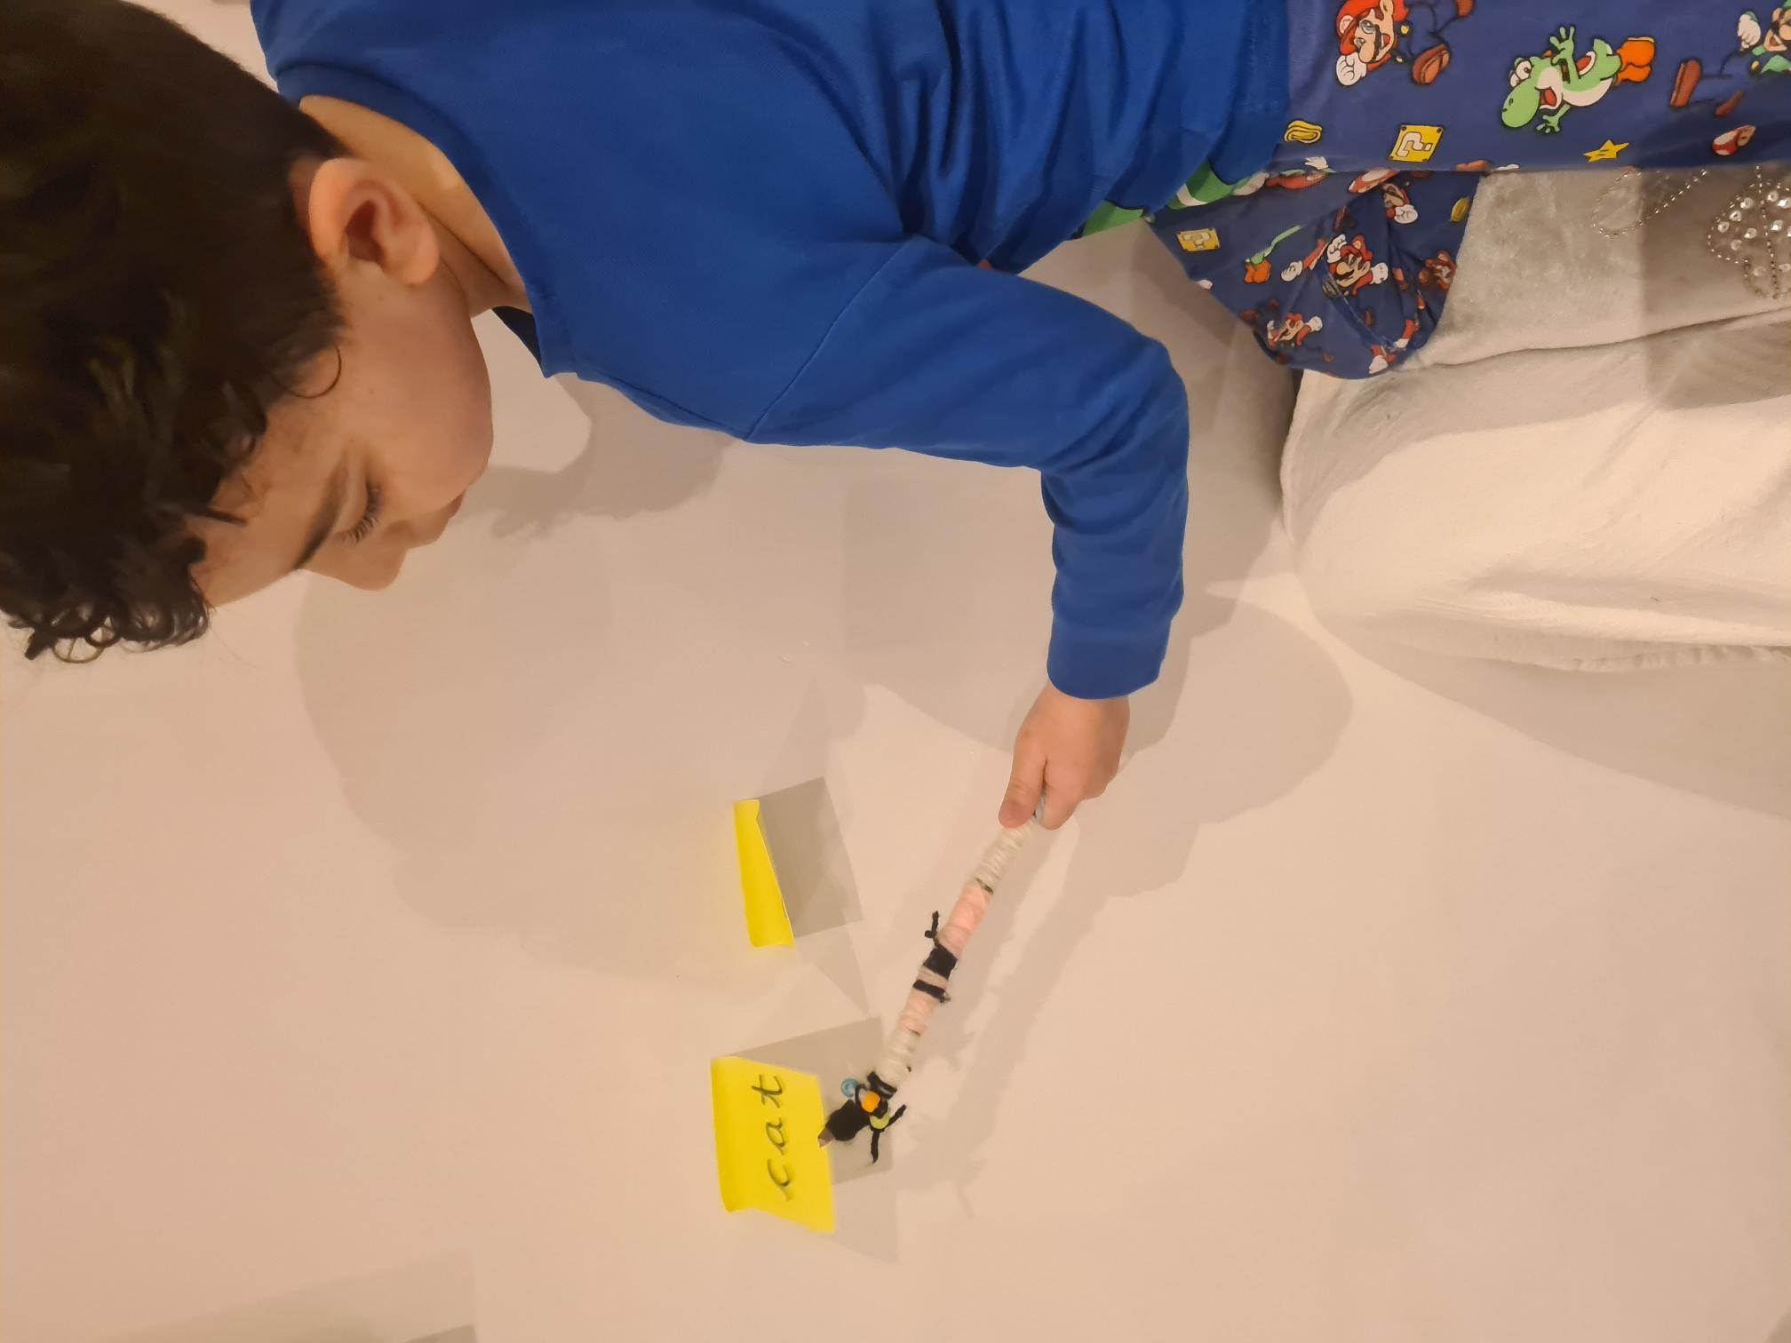 | How to:  - Explain to your child that you have a special reading challenge for them and that they are going to become a Word Wizard! All good wizards need a wand – support your child to find a stick outside and ask them to decorate it, using resources you have available at home. They could paint it, wrap it with wool/pipe cleaners, or even collage it with paper and/or other craft materials.  - While your child decorates their ‘wand’, prepare the word cards. Use post it notes or strips of paper/card to write 10 simple words e.g. nap, lap, cat, fat, dog, log, pin, bin, sun, fun. Hide the word cards around your house.  - Once your child’s ‘reading wand’ is ready, challenge your child to find the words hidden around the house. On finding a word, support your child to read the words by using their wand to point and say the sound each letter makes, before blending the sounds together e.g. c-a-t = cat! Encourage them to do this independently, but you can support them as needed. Continue until your child has found all of the hidden words.  - Read back the words to your child – can they use their wand to point at the words as you sound them out? For an extra challenge, ask them to group together the words that rhyme e.g. cat, fat
Adaptations:  - If your child is not yet confident in reading words, adapt the activity to become a ‘sound hunt’ instead using sounds and letters they know.  - For extra challenge, support your child to use the words/letters found to create a simple sentence/word. | You might need:  - A wooden spoon/stick  - Paint/craft materials to decorate the magic wand  - A magnifying glass  - Post it notes/paper/card  - Blu tac  - Writing materials

Top Tip: Use phonemes (sounds) and words that your child is familiar with and currently working on in their phonics learning at school.
Home Learning Cards Set 2: Card 14 of 14

